Part 1
- The diagrams below show two types of wave produced on a slinky spring.
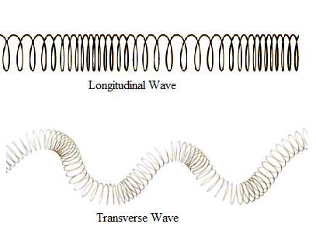
A
B

- Which one is a transverse wave? (1) Wave B

- What is the name of the other type of wave? (1) Longitudinal wave

- On both slinky diagrams, draw an arrow to show the direction of oscillation of the wave. (2)

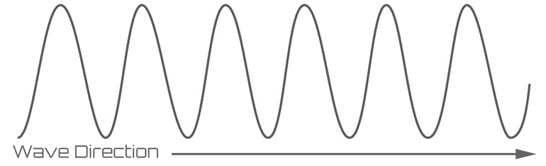
- On the diagram below, label the amplitude (a) and wavelength (λ) of the wave. (2)
λ

a

- Radio waves from a distant galaxy are travelling at 3.0 x 10⁸m/s. If they have a wavelength of 28m, calculate the frequency of these waves. (3)

v = f x λ (1) f = v/λ (1) f = 3.0 x 10⁸
28

Frequency = 10.7 MHz (1)

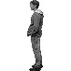
- The man sees the lightening and hears the thunder 4s later. The lightening hit the ground 1.3km away. Use this information to calculate the speed of sound in air. (2)


Speed = distance (1) Speed = 1300
time 4
Speed of sound in air = 325m/s (1)

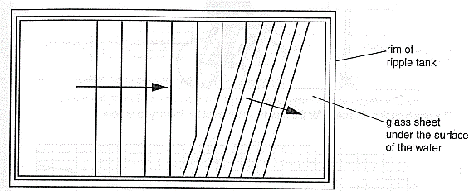
- The water waves produced in a ripple tank are shown below.
Bar producing the waves

- The bar producing the waves is vibrating at 2Hz and the waves are 0.03m apart. Calculate the speed of the water waves. (2)

v = f x λ (1) v = 2 x 0.03 = 0.06

Speed of water waves = 0.06m/s (1)

- When the wave passes over the glass it refracts. State what will happen to each of the following properties of the wave when it refracts: (3)

Velocity decreases / slows down

Wavelength decreases

Frequency remains the same

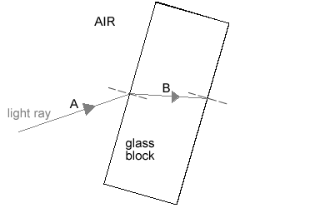
- The diagram shows a light ray shining on a block of glass.

D
C

- What is happening to the light ray at B? (1) Refracting (slowing down)

- Continue the ray of light as it leaves the glass block and label this as C. (1)

- Some of the light will be reflected before it enters the block. Draw this reflected ray and label
it D. (1)

- Not all the light that enters the block leaves the block. What has happened to this light that
does not leave the block? (1)
It has been absorbed by the glass
- (physics only) Sound waves in the air are converted into vibrations in solids within the ear (HT).
- Describe how the ear changes air vibrations into solid vibrations. (3)
Compressions in the air caused by sound (1) make the flexible eardrum vibrate (1)

Solid bones are connected to the eardrum which also vibrate as the eardrum vibrates (1)

- Explain why this process limits the frequency range humans can hear. (3)
The eardrum and solid bones can only vibrate at specific frequencies (1)
Faster or slower vibrations in the air do not produce vibrations in the bones (1)
This limits the frequency of sound that can be heard (1)

- The diagram below shows ultrasound being used to produce an image of the inside the body.

muscle
fat
skin
Ultrasound emitter/receiver
screen
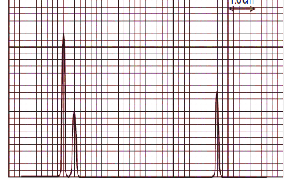

- Complete the following sentences. Choose from the correct words from the list below. (4)
media radiated transmitted reflected boundary
Ultrasound can travel through different materials – solids, liquids and gases. When
ultrasound meets a boundary between two different
media some of the ultrasound is reflected/transmitted and some is
transmitted/reflected . The reflected pulses are seen on the screen.
- Draw a trace on the screen to show how the ultrasound image will appear. (2)
Spikes showing strong initial peak (1) then two subsequent peaks reflected from fat and muscle boundaries (1)

- The diagram shows how Primary and Secondary seismic waves travel through the Earth.
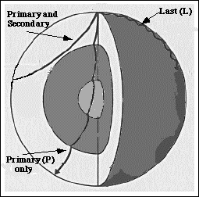

- What type of waves are S waves? (1)
Transverse waves
- Why do the S waves not travel all the way through the Earth? (1)
S waves cannot travel through liquids
- The P waves bend when they come to a new boundary surface. What is this bending
called? (1)
Refraction
d. Explain why the P waves bend in this way. (3)
There is a difference in density at boundaries between different layers in the Earth(1)
When the P wave meets a boundary, one side of the wave slows down before the
other side (1)

This change in speed causes the wave to bend (1)

- Describe how echo sounding is used to locate a shoal of fish under a fishing trawler. (4)
A sound pulse is sent directly down into the water (1)
The sound wave is reflected off the fish and received on board the trawler (1)
If the speed of sound in water and the time for the pulse to return are known (1)
the depth of the shoal of fish can be calculated using speed = distance/time (1)

